API GETWAY GET

- Create a lambda function write the code and deploy it.
import json

def lambda_handler(event, context):
# A simple Lambda function that handles a GET request from API Gateway

# This is the data you want to return
response_data = {
"message": "Hello! Your GET request was received successfully.",
"status": "success"
}

# This is the required response format for API Gateway
return {
"statusCode": 200,
"headers": {
"Content-Type": "application/json"
},
"body": json.dumps(response_data)
}

- Create event, lambda → functions → your lambda function → test → create event after test this event then its run successful.
- 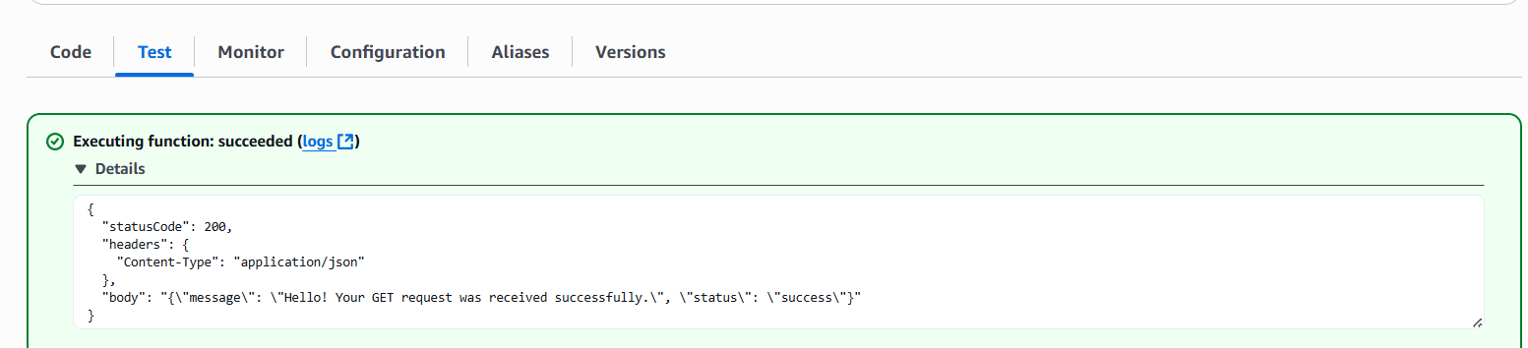
- Now create api select http api.
- Now integrate this api with lambda function, first create route select get and intergrate
- 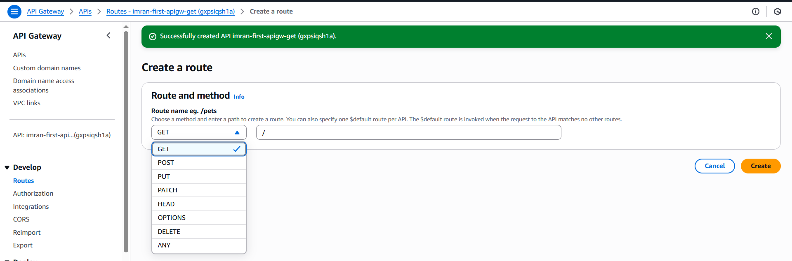
- 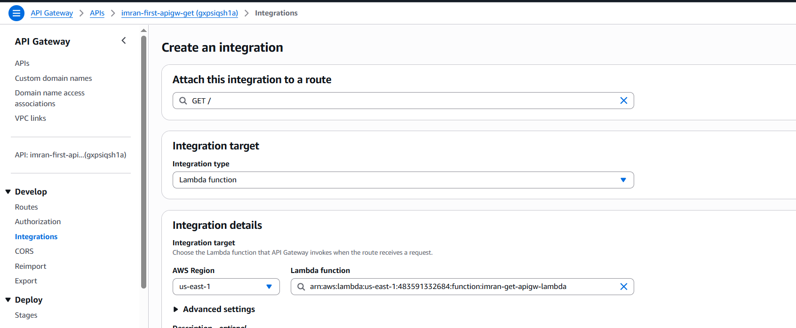
- 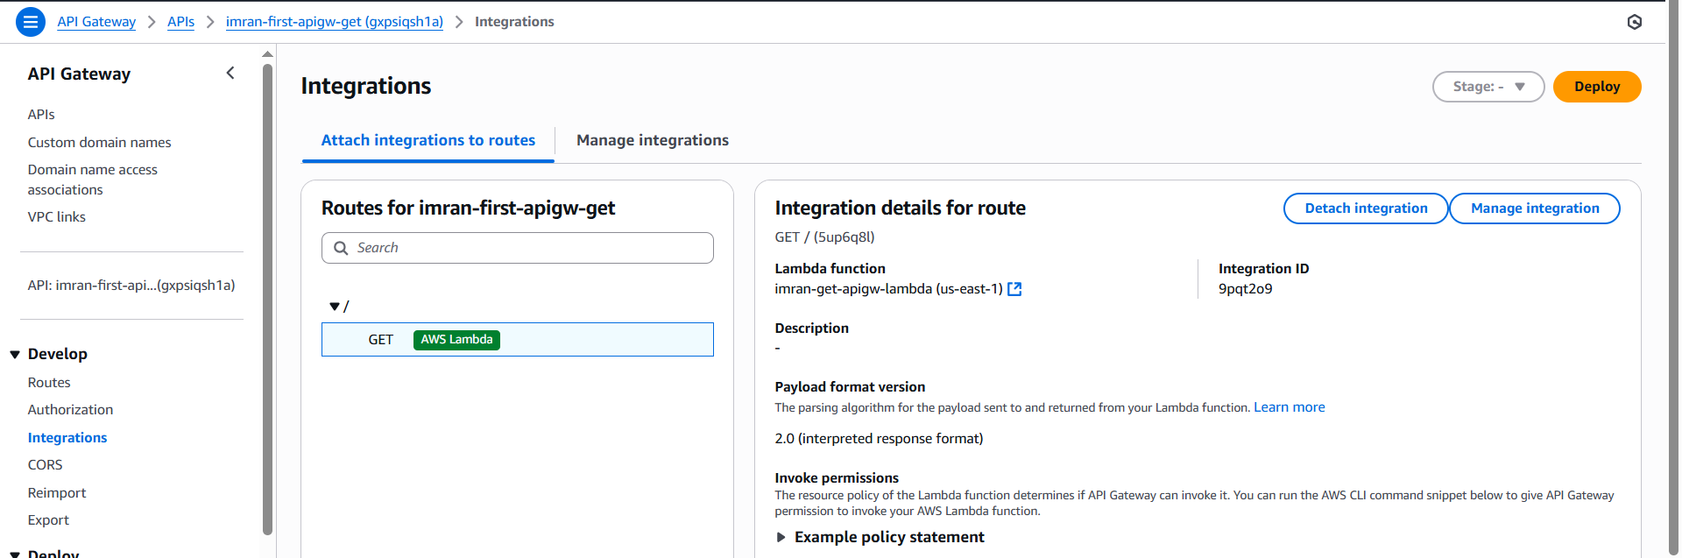
- Now you need to take url of your api to access get api
https://gxpsiqsh1a.execute-api.us-east-1.amazonaws.com/
- 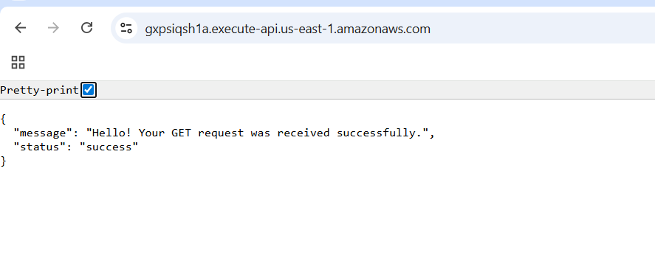
- To check put and other methods install postman api software in laptop and check.
- 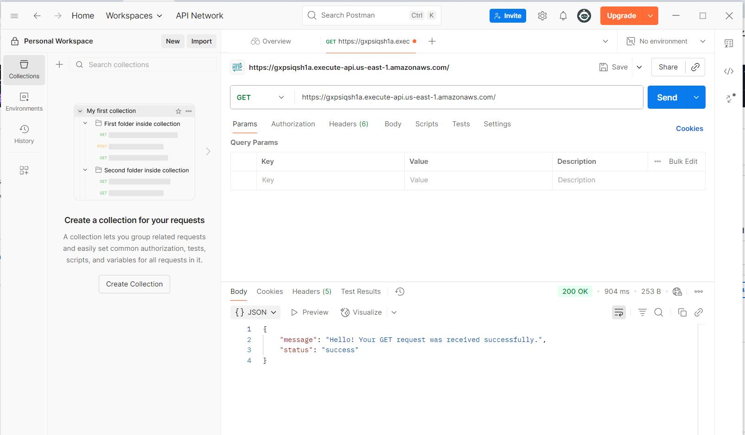

TASK: Rest api for the non proxy integration

- Create a lambda function and write the code and deploy it and test.
import json

def lambda_handler(event, context):
# Try to get 'name' directly from event (if passed in test payload)
name = event.get('name')

# If 'name' not found, check query string parameters
if not name:
params = event.get('queryStringParameters', {})
name = params.get('name', 'world') # default to "world" if not provided

# Return response
return {
"statusCode": 200,
"headers": {
"Content-Type": "application/json"
},
"body": json.dumps({
"message": f"Hello, {name}!"
})
}

- 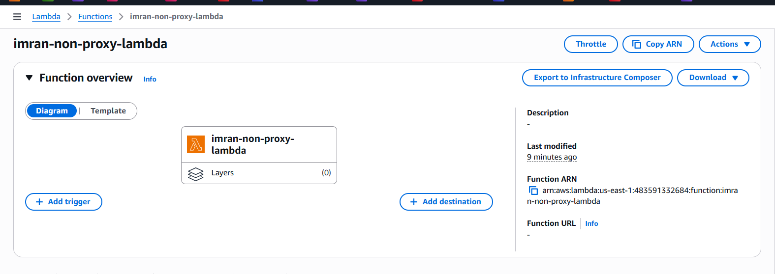

- 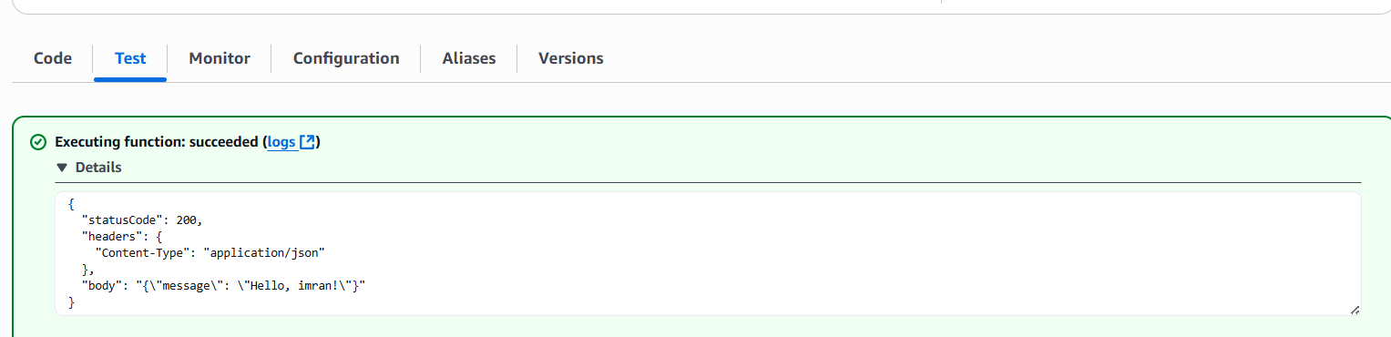
- Now create api gateway using rest api
- Then create resource and create method
- 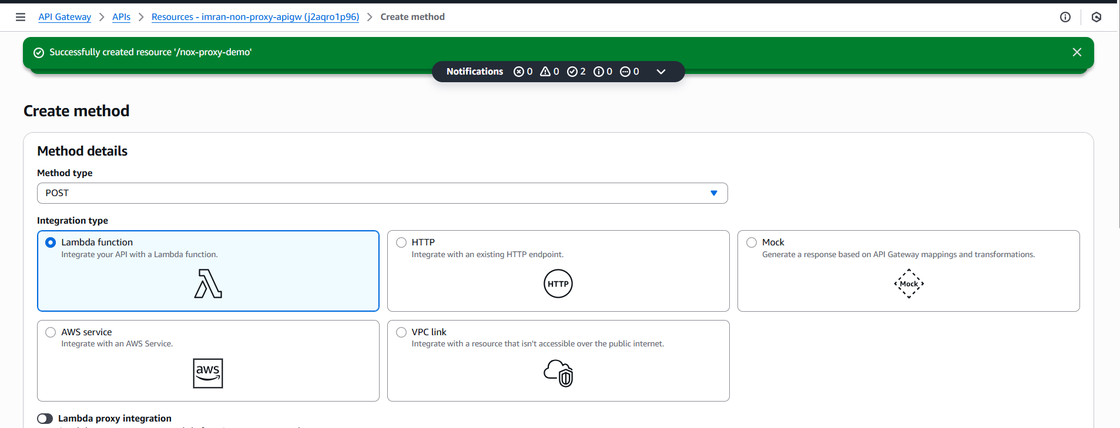
- Now edit method request, integration request and save and deploy.
- 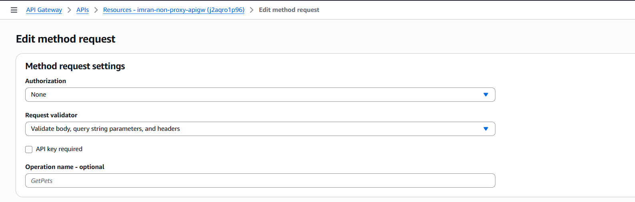
- 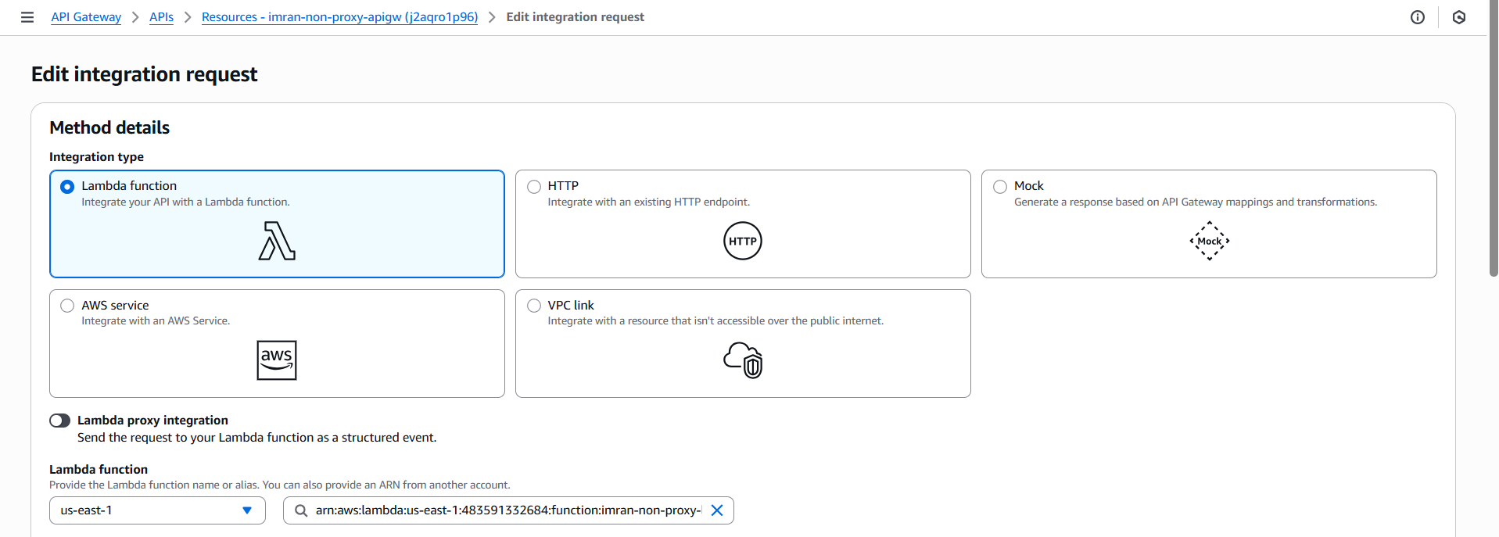
- And now in mapping templates write the code .
#set($originalParam = $input.params('name'))
#set($prefix = "prefix_")

#if(!$originalParam.startsWith($prefix))
#set($originalParam = $prefix + $originalParam)
#end

{
"name": "$originalParam"
}

- Now test and deploy take new stage with name dev
- 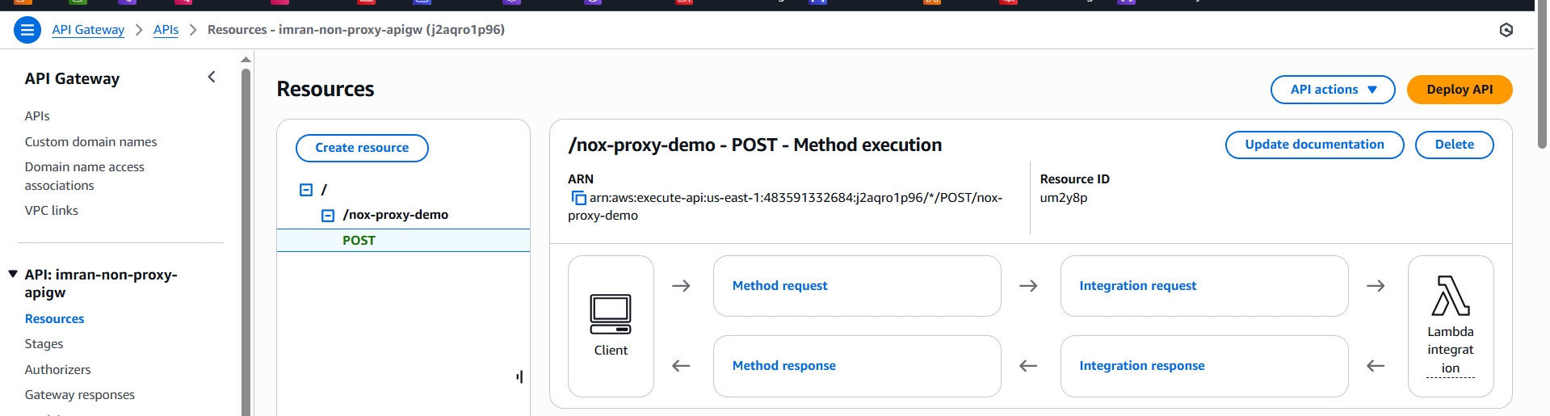
- 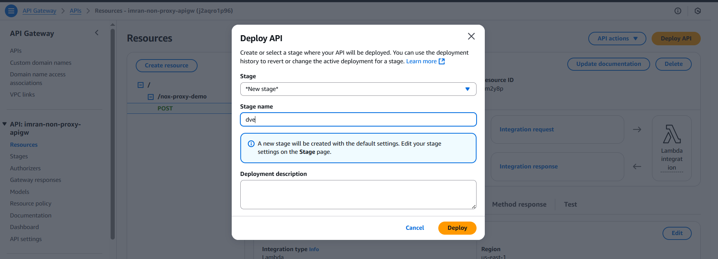
- Take the url
- 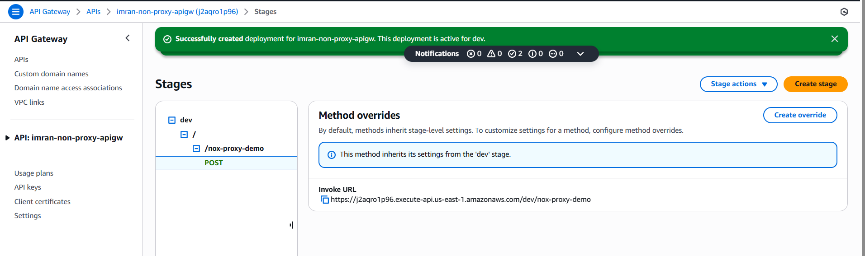
- Now check in postman app with the post method you can add name and value
- https://j2aqro1p96.execute-api.us-east-1.amazonaws.com/dev/nox-proxy-demo
- 